EduTutor AI – Personalized Learning

Project Documentation  
Project done by

1. DHIVYA BHARATHI M
2. DHANASHRI M
3. DHARSHINI N
4. DEEPIKA E

# 1. Abstract / Overview

EduTutor AI is a personalized learning assistant built using IBM Granite models on Hugging Face. It generates concept explainers, quizzes, and interactive study tools. The project leverages Google Colab for deployment and Gradio for the user interface, making it lightweight and accessible.

# 2. Objectives

* To explore and integrate IBM Granite models.
* To build a Gradio-based learning assistant.
* To deploy in Google Colab with GPU acceleration.
* To manage and share the project via GitHub.

# 3. Prerequisites

* Python programming knowledge
* Gradio framework basics
* IBM Granite model access (Hugging Face)
* Google Colab (T4 GPU) usage
* Git & GitHub for version control

# 4. System Requirements

* Google Colab (T4 GPU enabled)
* Python 3.x
* Libraries: transformers, torch, gradio

# 5. Project Workflow

# Activity 1:-Exploring “Naan Mudhalvan Smart Internz” Portal

Search for “Naan Mudhalvan Smart Internz” portal in any browser.  
2. Login with your details.  
3. Go to 'Projects' section and select 'EduTutor AI'.  
4. Access resources and guided project.

Step 1:-

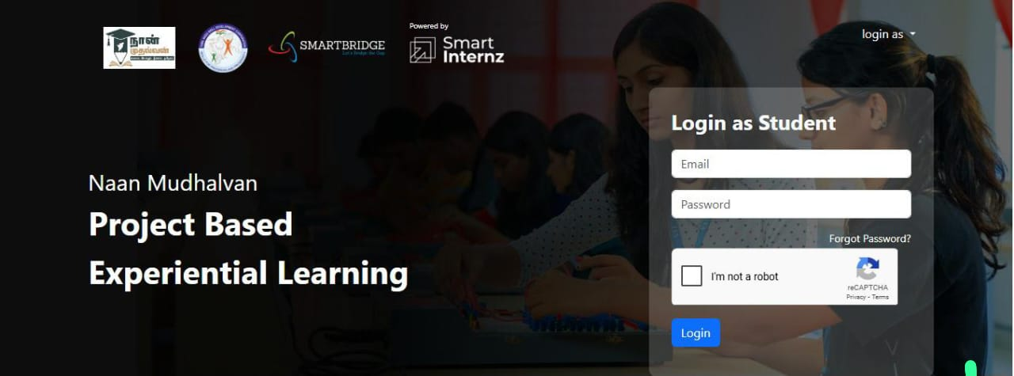

Step2:-

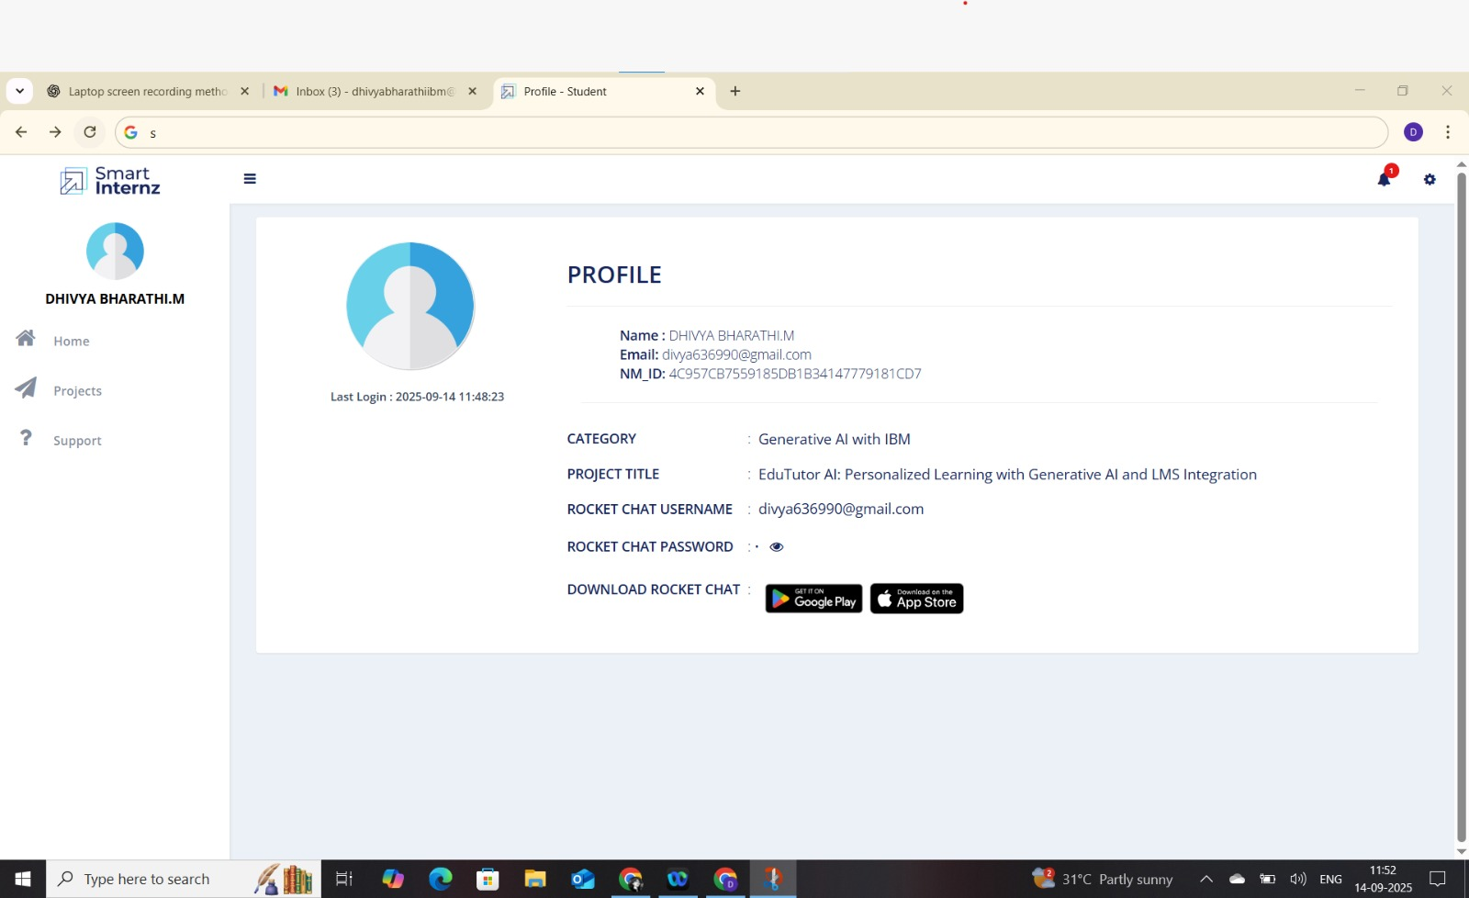

Step3:-

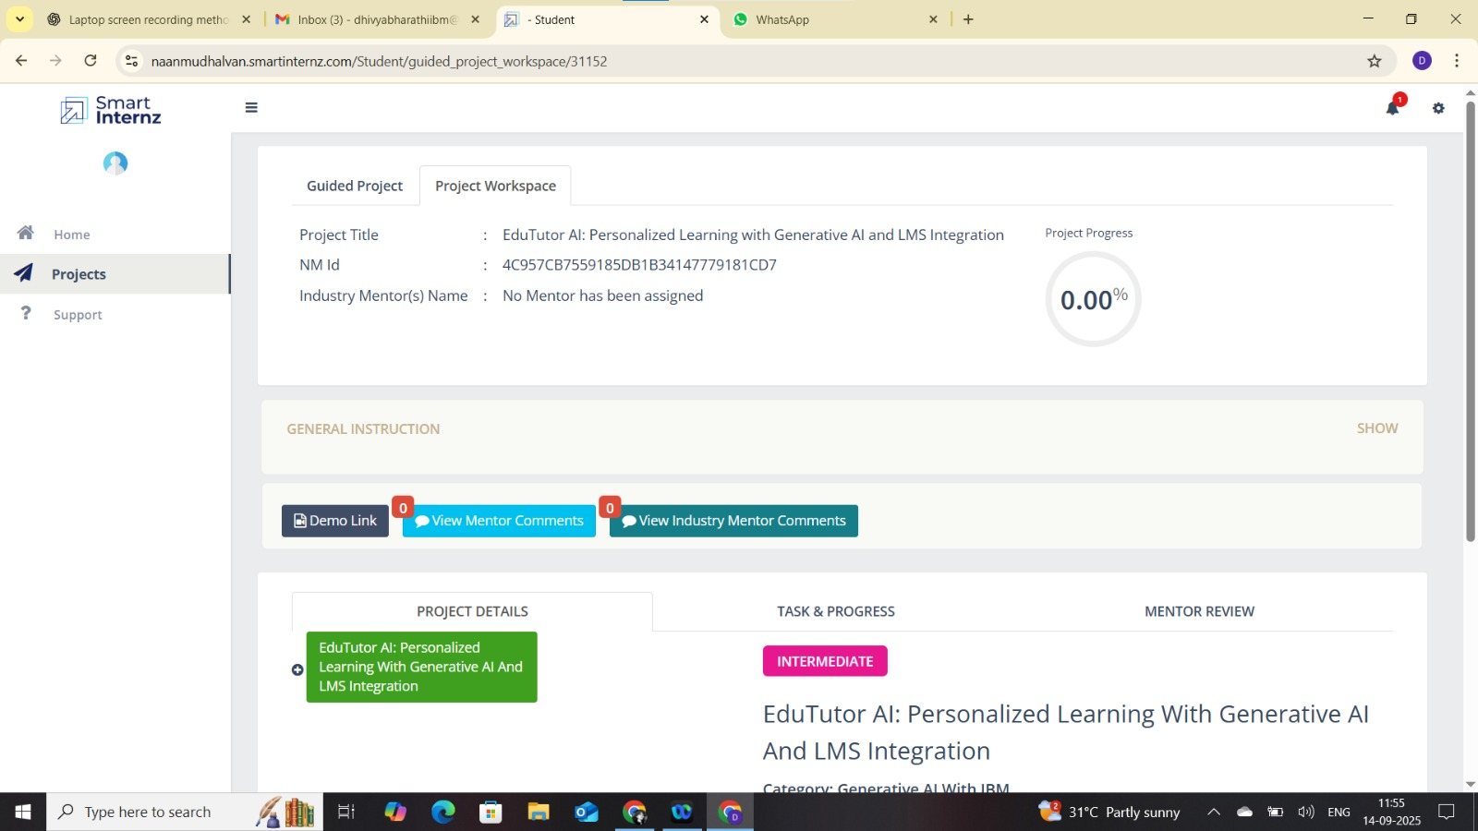

## Activity 2: Choosing IBM Granite Model (Hugging Face)

1.Visit Hugging Face and create an account.  
2. Search for 'IBM-Granite models'.  
3. Choose a model (here: granite-3.2-2b-instruct) for fast and lightweight performance.

Step1:-

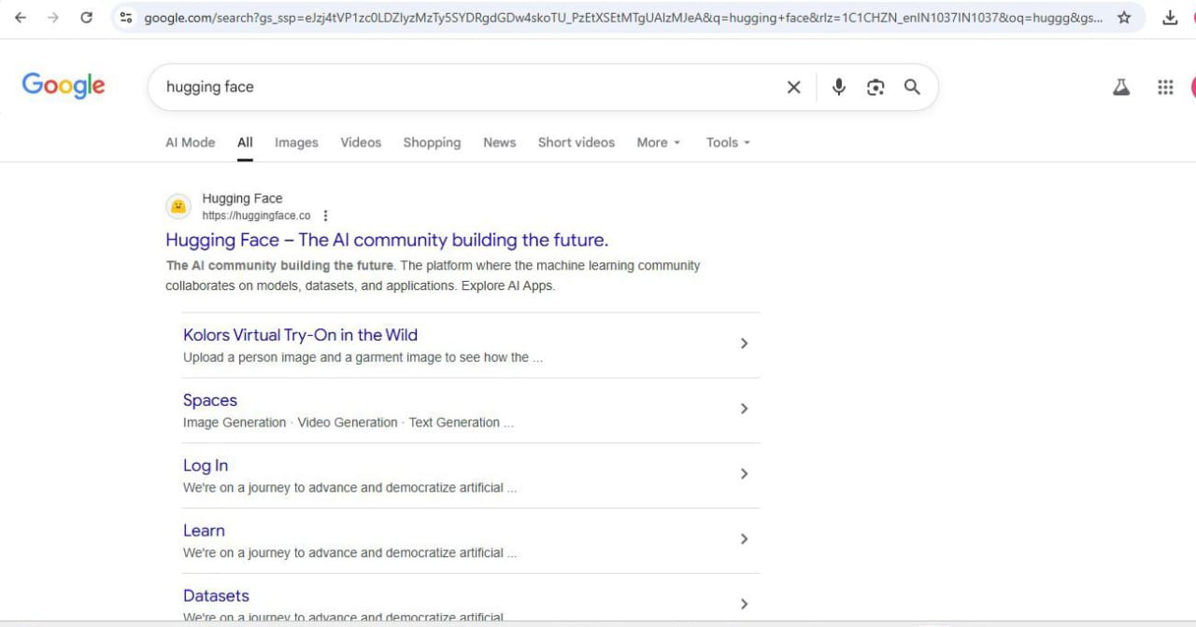

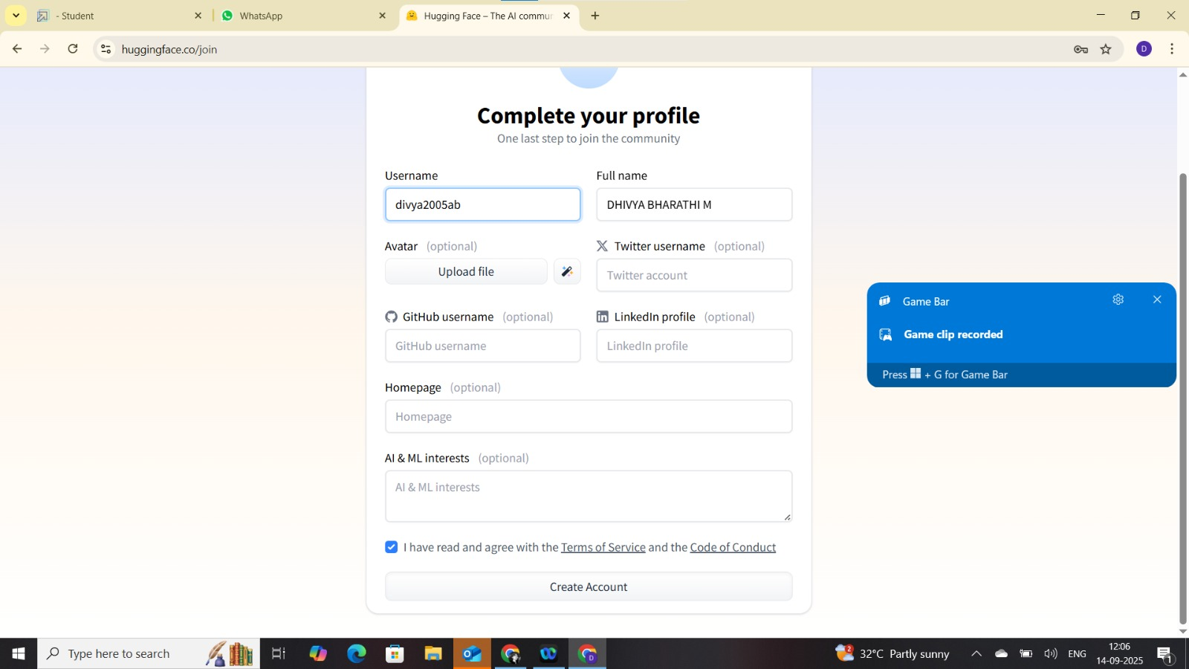

Step2:-

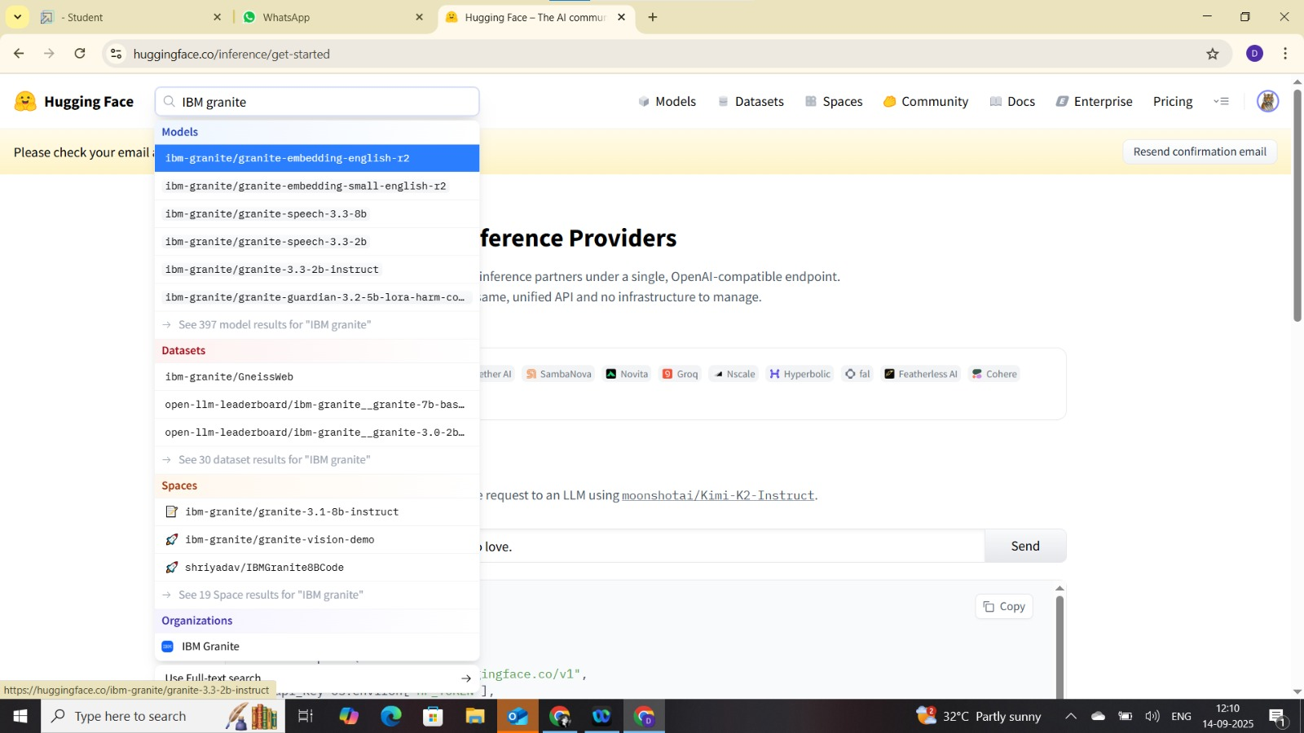

Step3:-

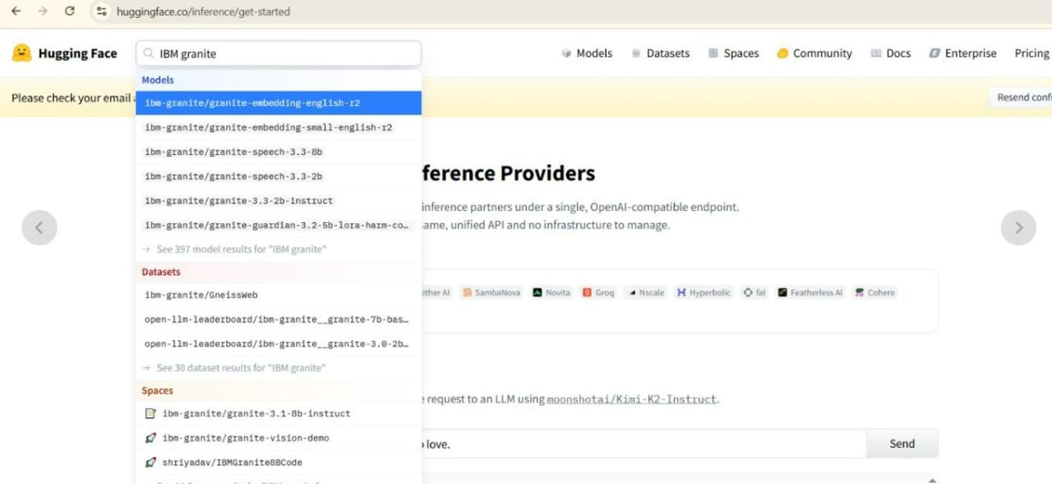

Activity 3: Running in Google Colab

1. Open Google Colab and create a new notebook.  
2. Change runtime type to T4 GPU.  
3. Install required libraries using:  
 ***“!pip install transformer torch gradio - q”.***

4. Run the EduTutor AI code from provided source.  
5. Launch the Gradio application and test the output.

Step 1:-

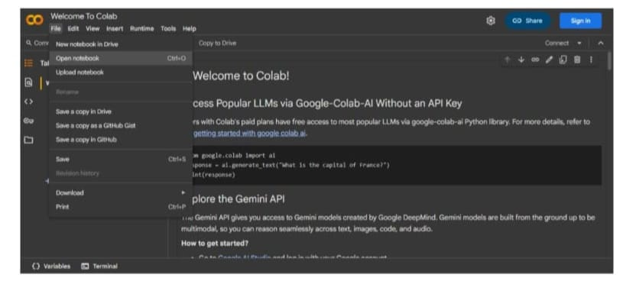

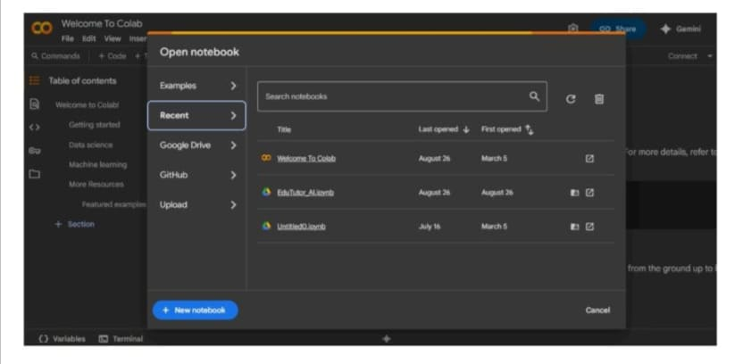

Step2:-

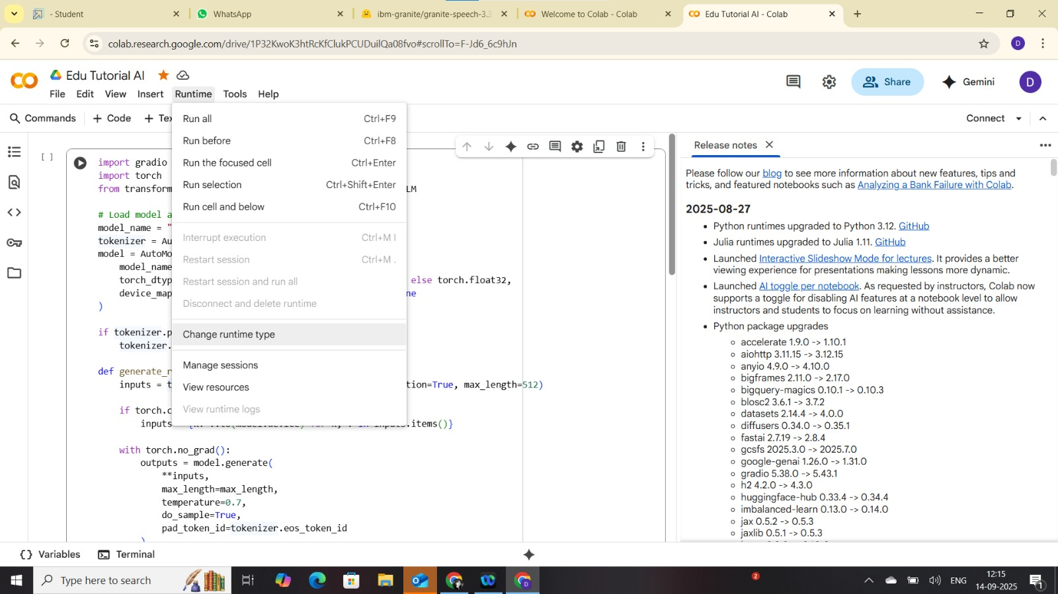

Step3:-

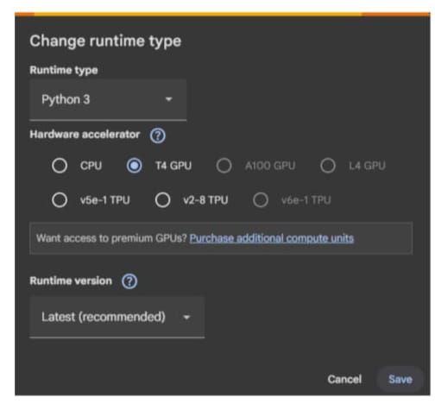

Step4:-

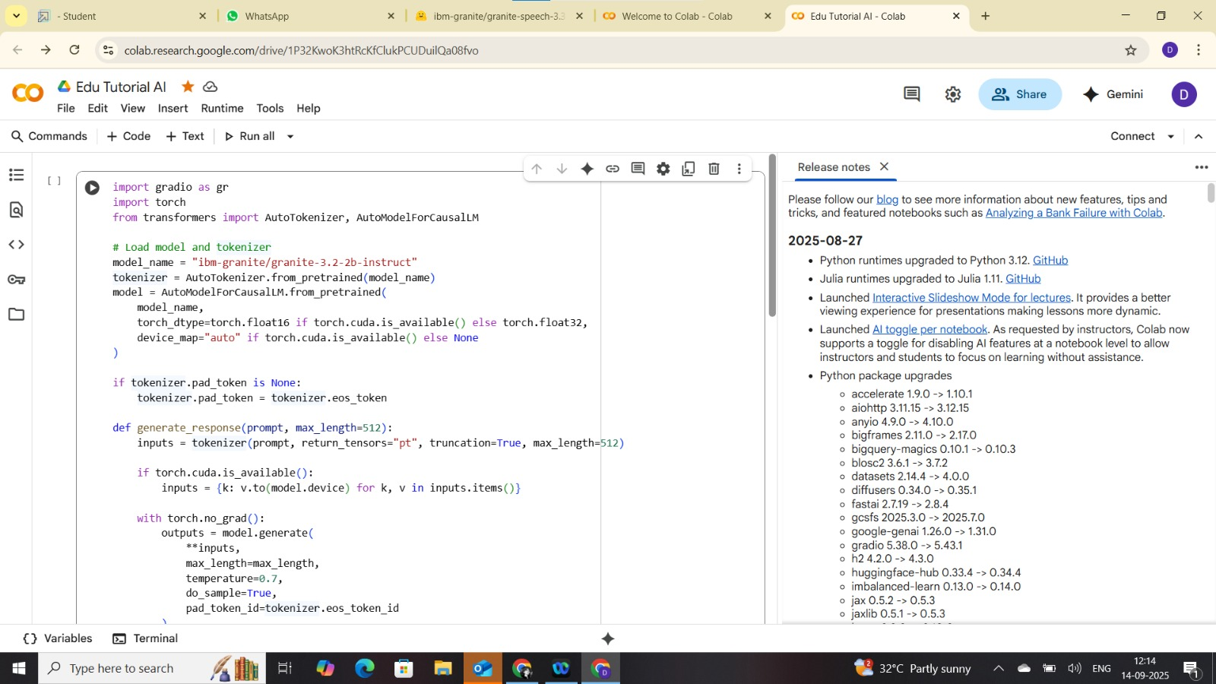

Step5:-

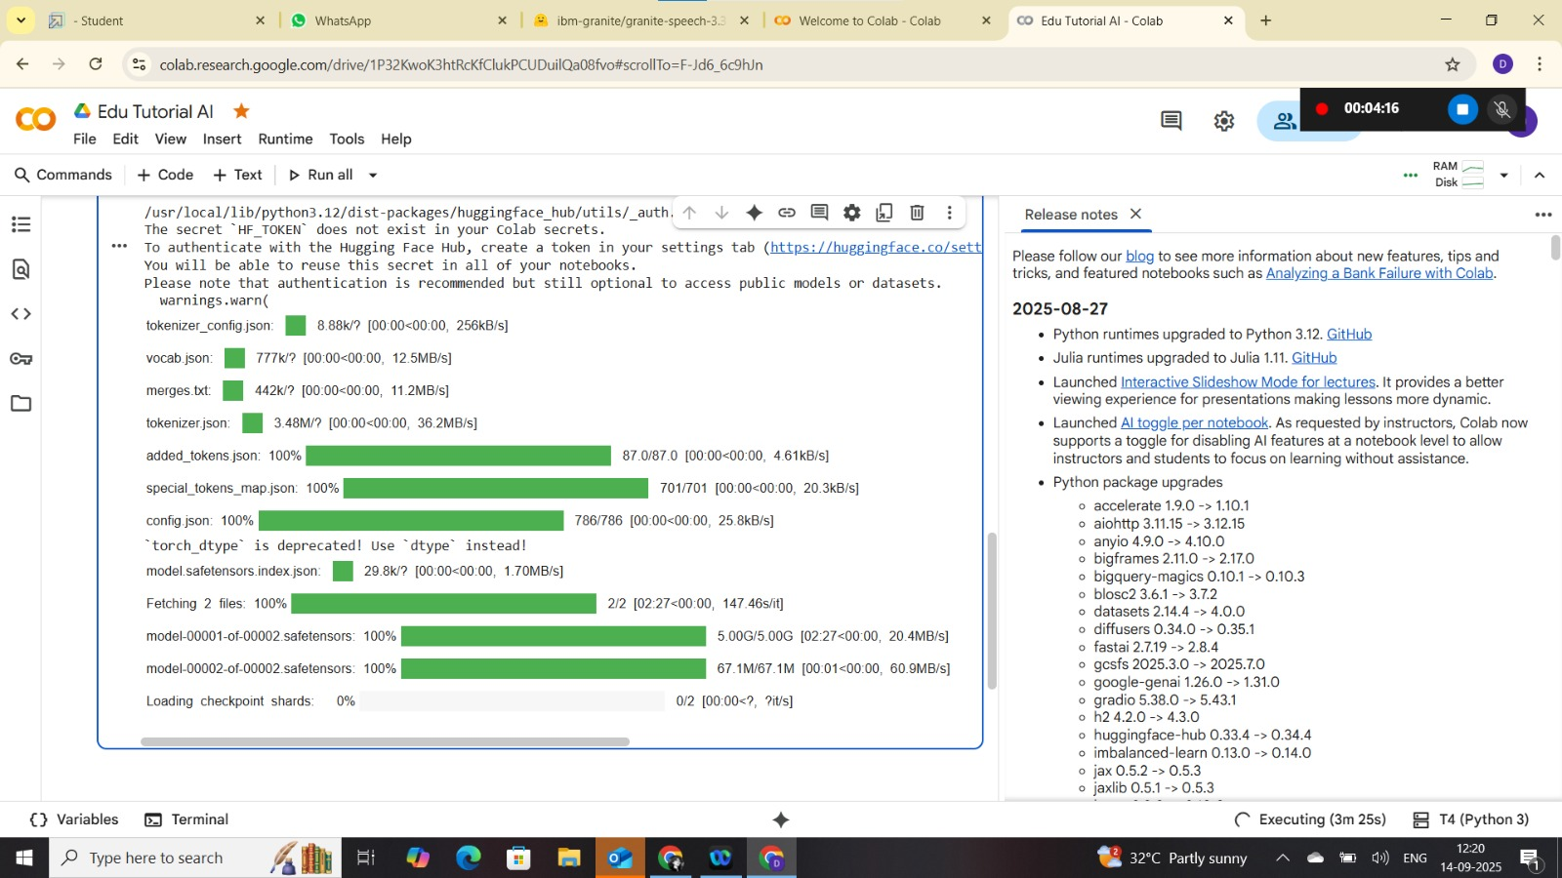

Step6:-

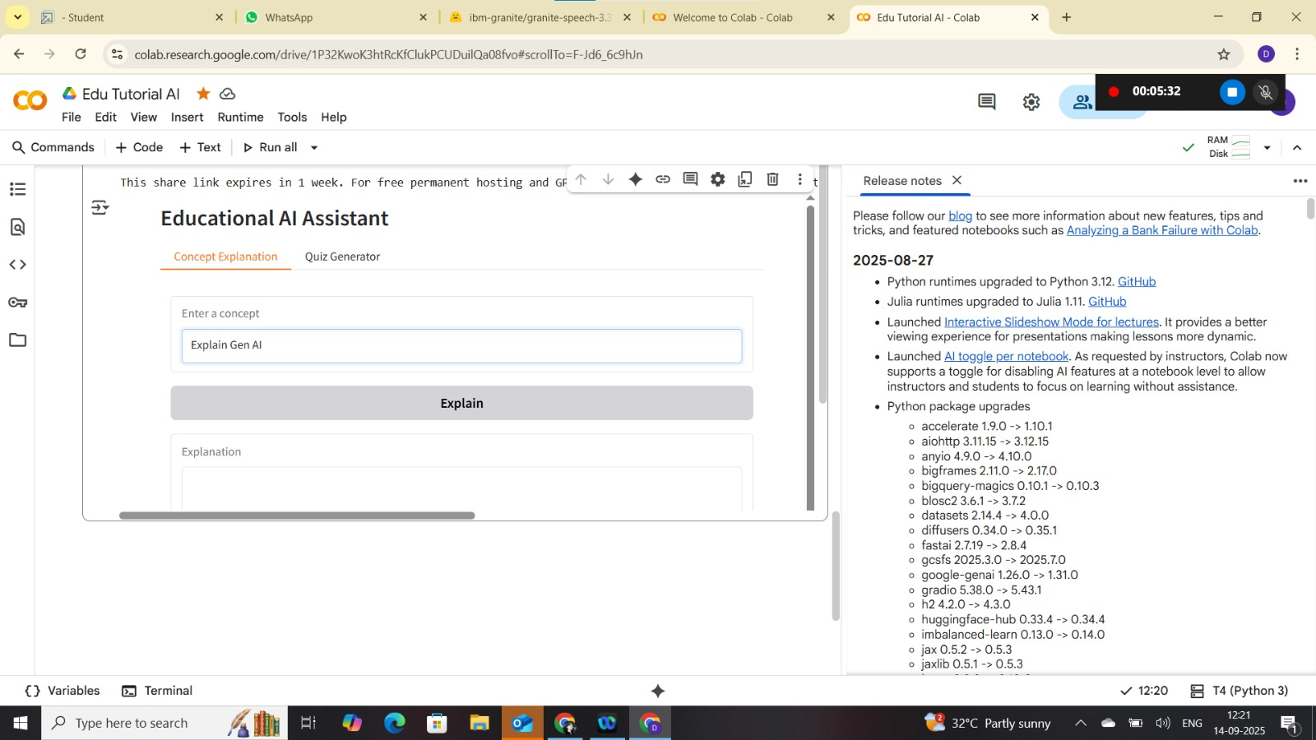

Step7:-

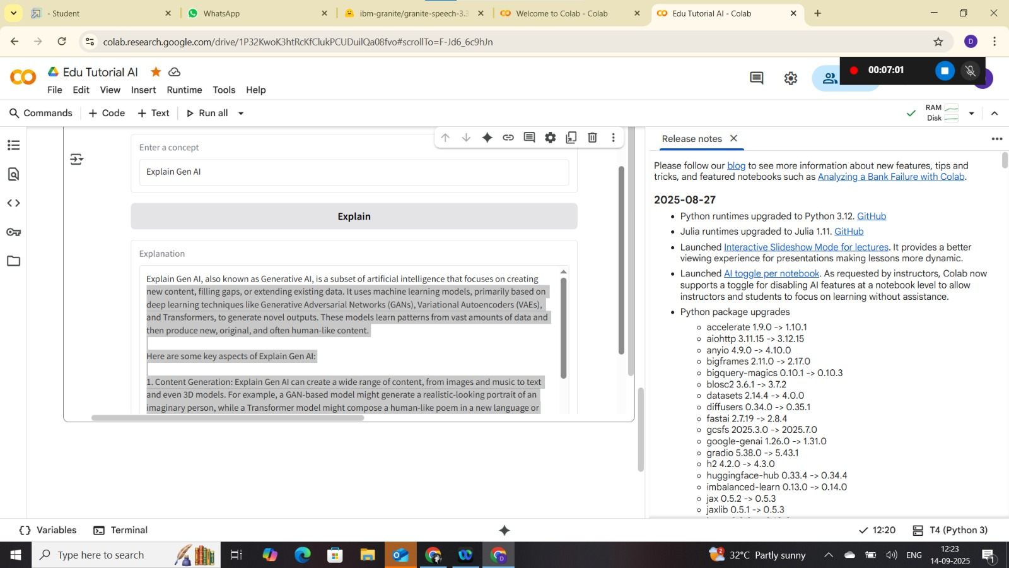

Step8:-

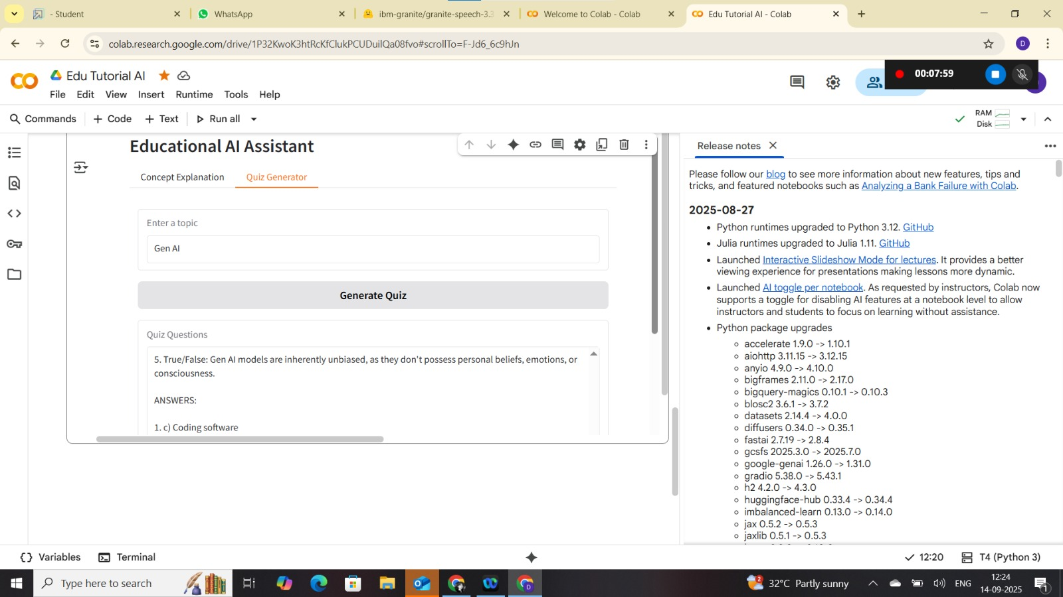

# Results & Output

The application successfully runs on Google Colab with Gradio interface. Users can generate personalized quizzes and concept explanations. Screenshots of the working app should be included here.

## Activity 5: Uploading to GitHub

1. Create a GitHub account and repository.  
   2. Download project code from Google Colab.  
   3. Upload files to GitHub repository.  
   4. Commit changes and share repository link.

Step 1:-

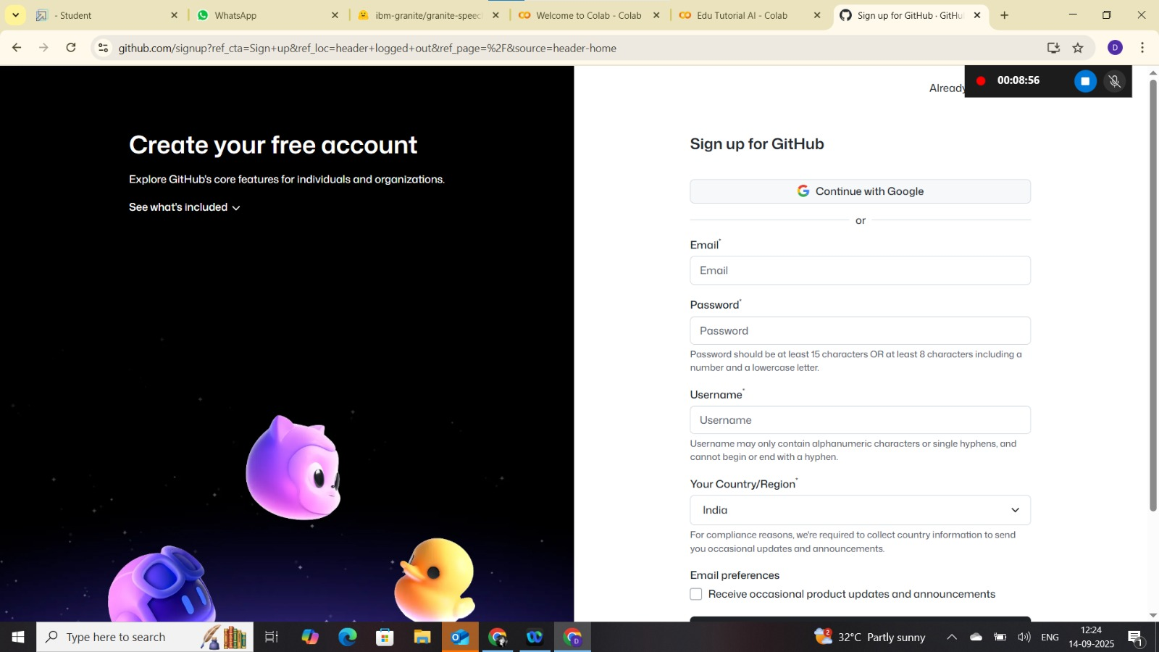

Step 2 :-

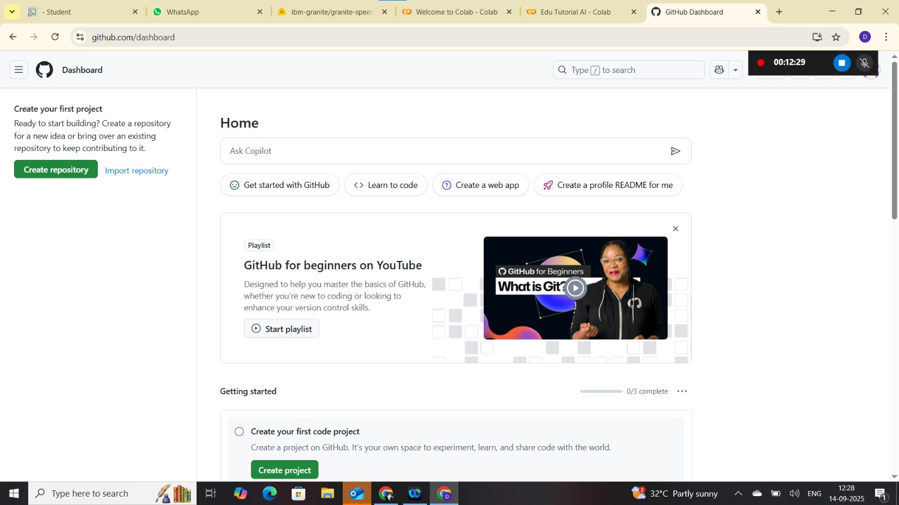

Step 3 :-

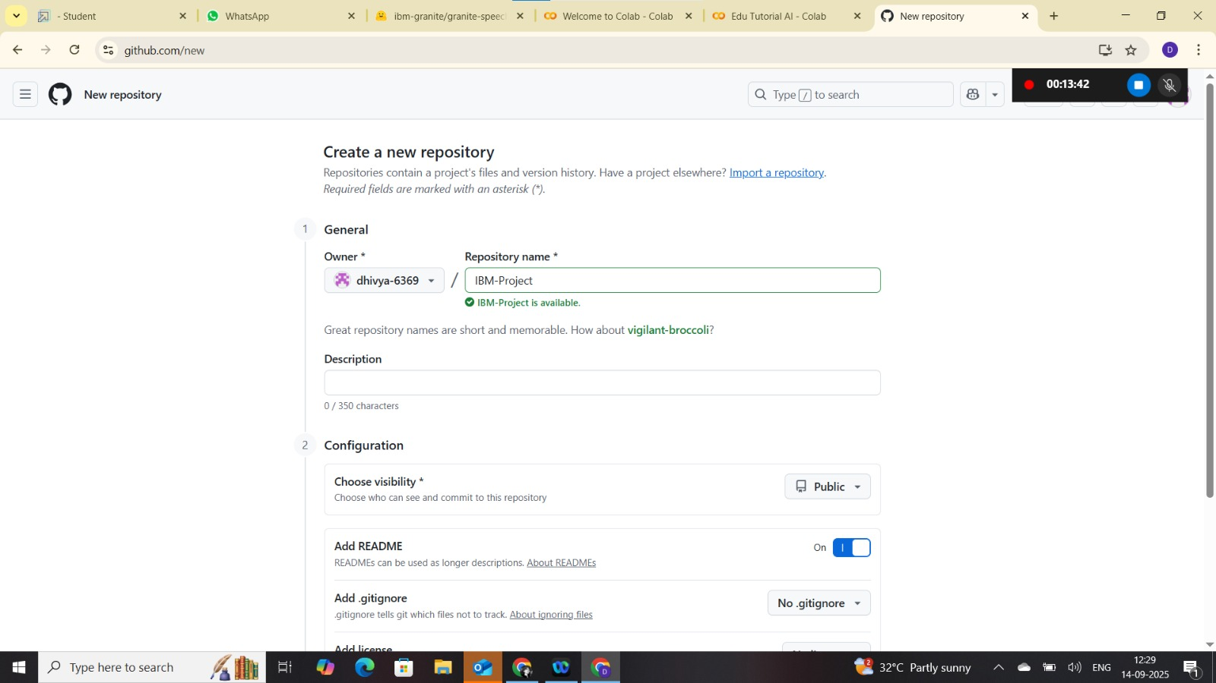

Step 4 :-

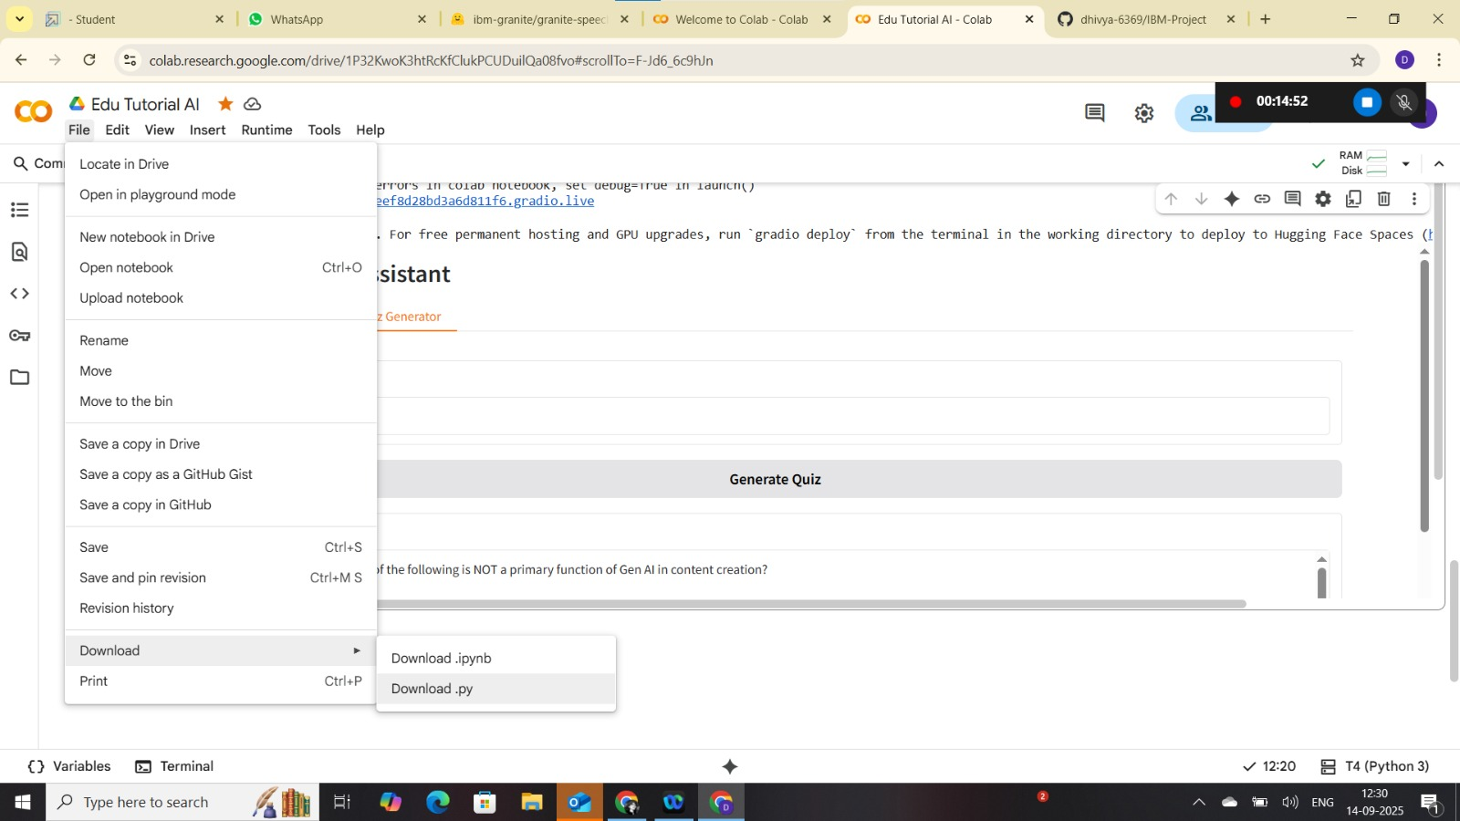

Step 5:-

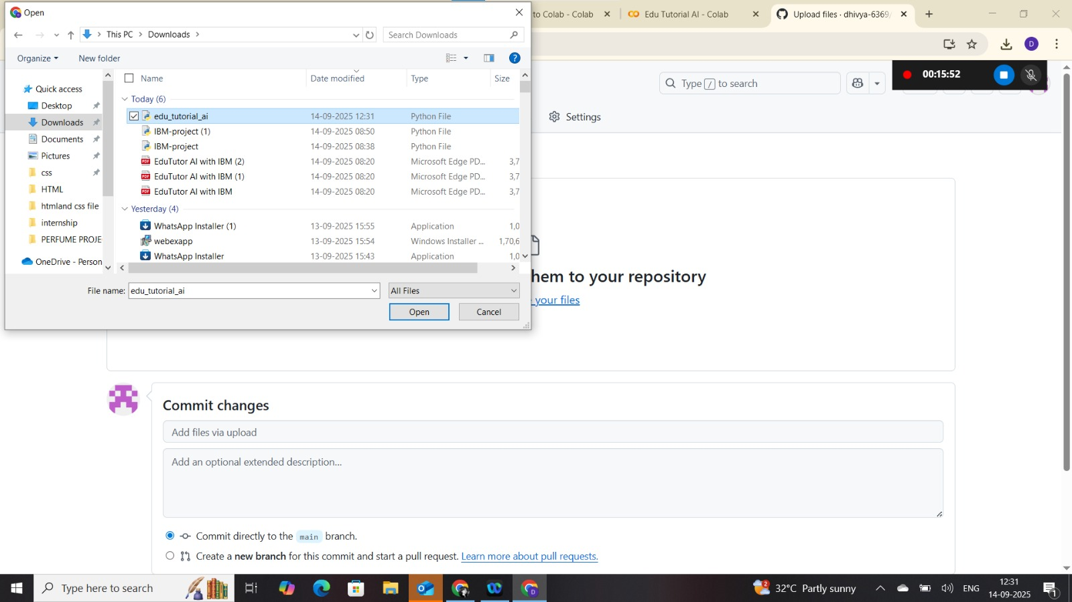

Step 6:-

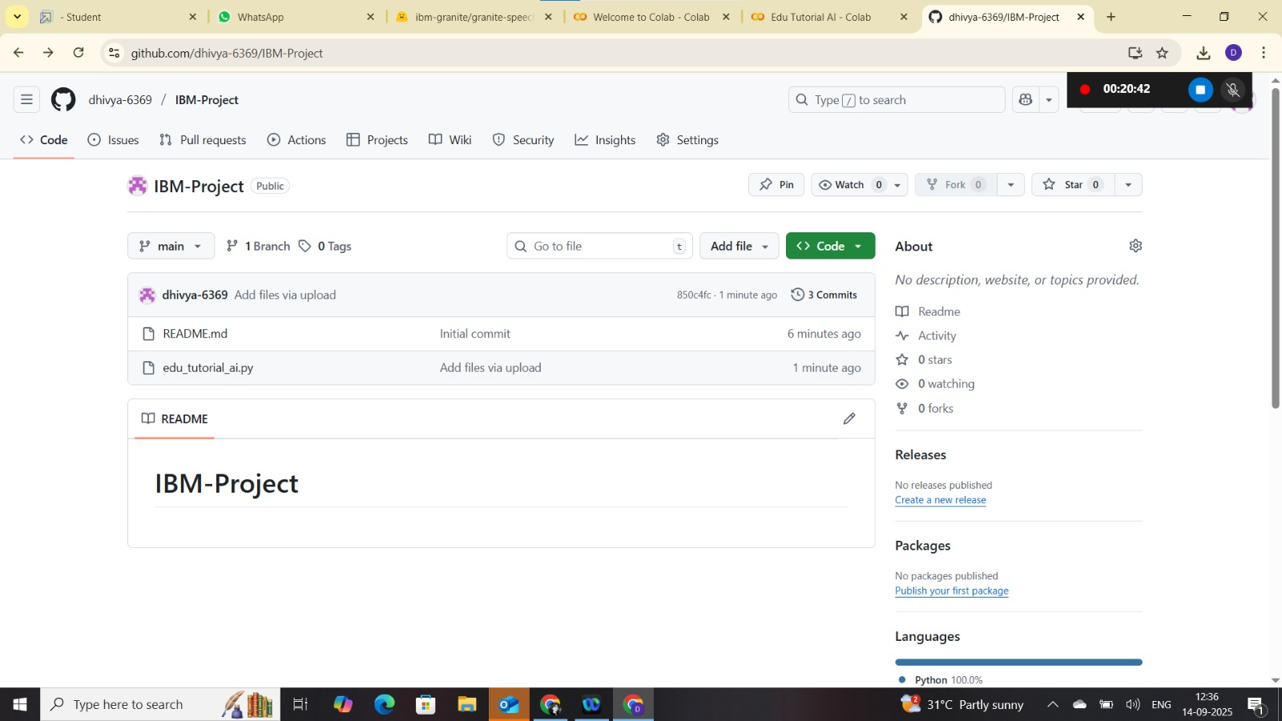

Step 7:-

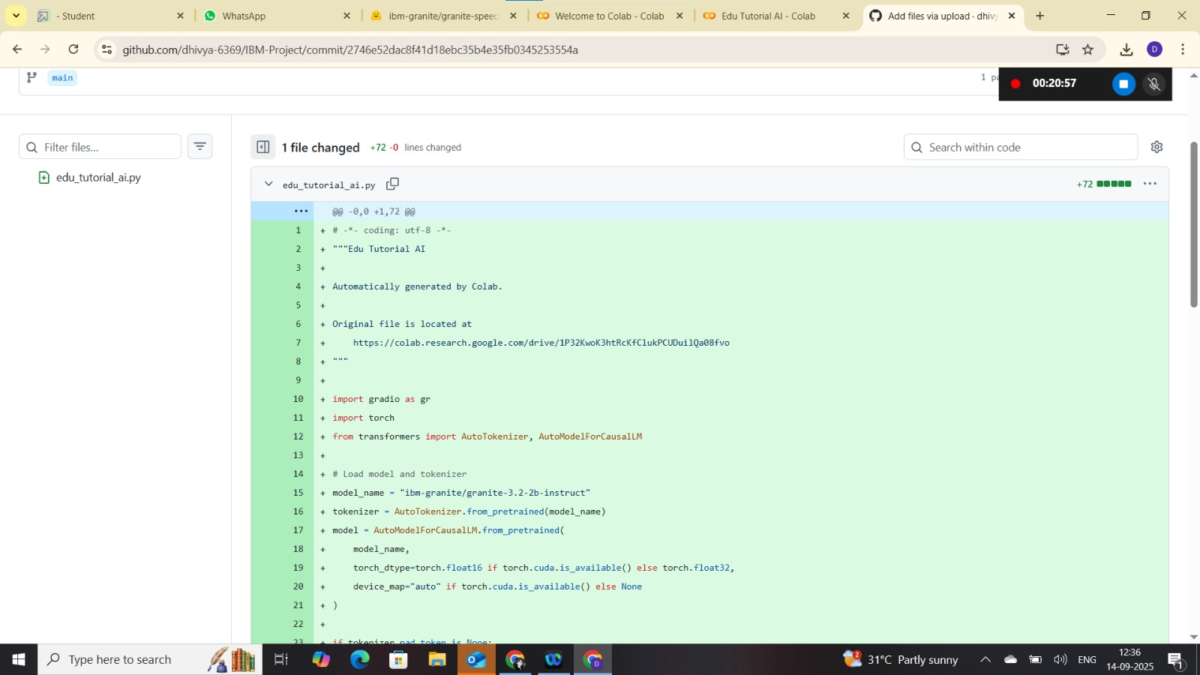

# 7. Challenges Faced

- Model loading time in Colab due to large model size.  
- GPU runtime limits in free Colab tier.  
- Initial learning curve for Hugging Face and Gradio integration.

# 8. Future Enhancements

* Add voice-based interaction.
* Enable multi-language support.
* Deploy on cloud platforms (AWS, IBM Cloud, etc.).

# 9. Conclusion

EduTutor AI demonstrates how IBM Granite models can be integrated into a lightweight learning platform. This project showcases practical skills in AI model integration, cloud-based execution, and collaborative version control.